DataDogs Documentation

Provision an EC2 instance with Amazon Linus OS:

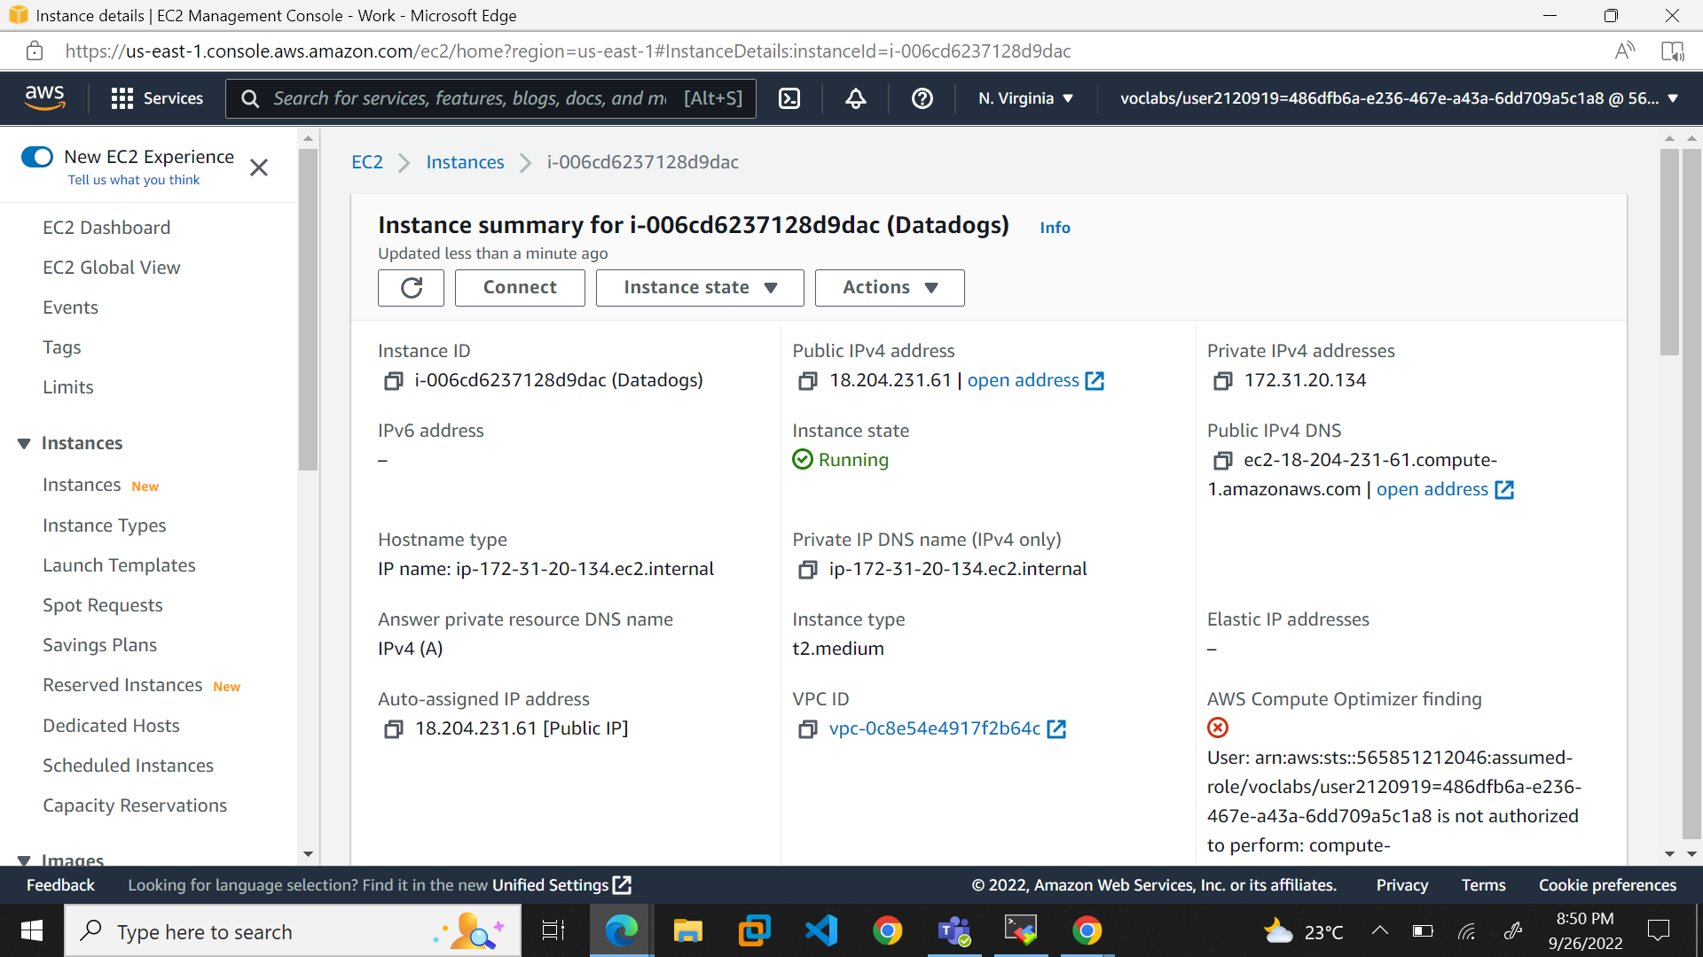

SSH into the EC2 instance

Now we have to setup the agent for Amazon Linux OS:

Navigate to Agent and select the OS, we are using Amazon Linux OS

Enter the API key into the bash script from the root user:

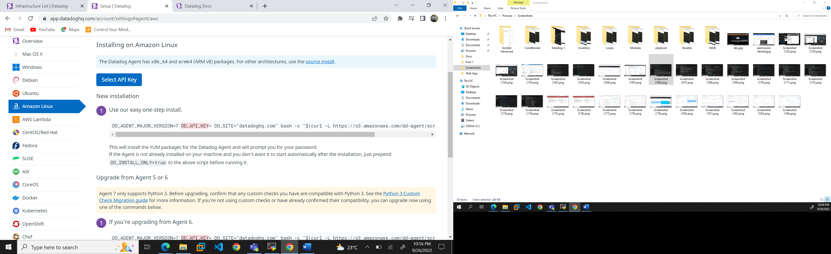

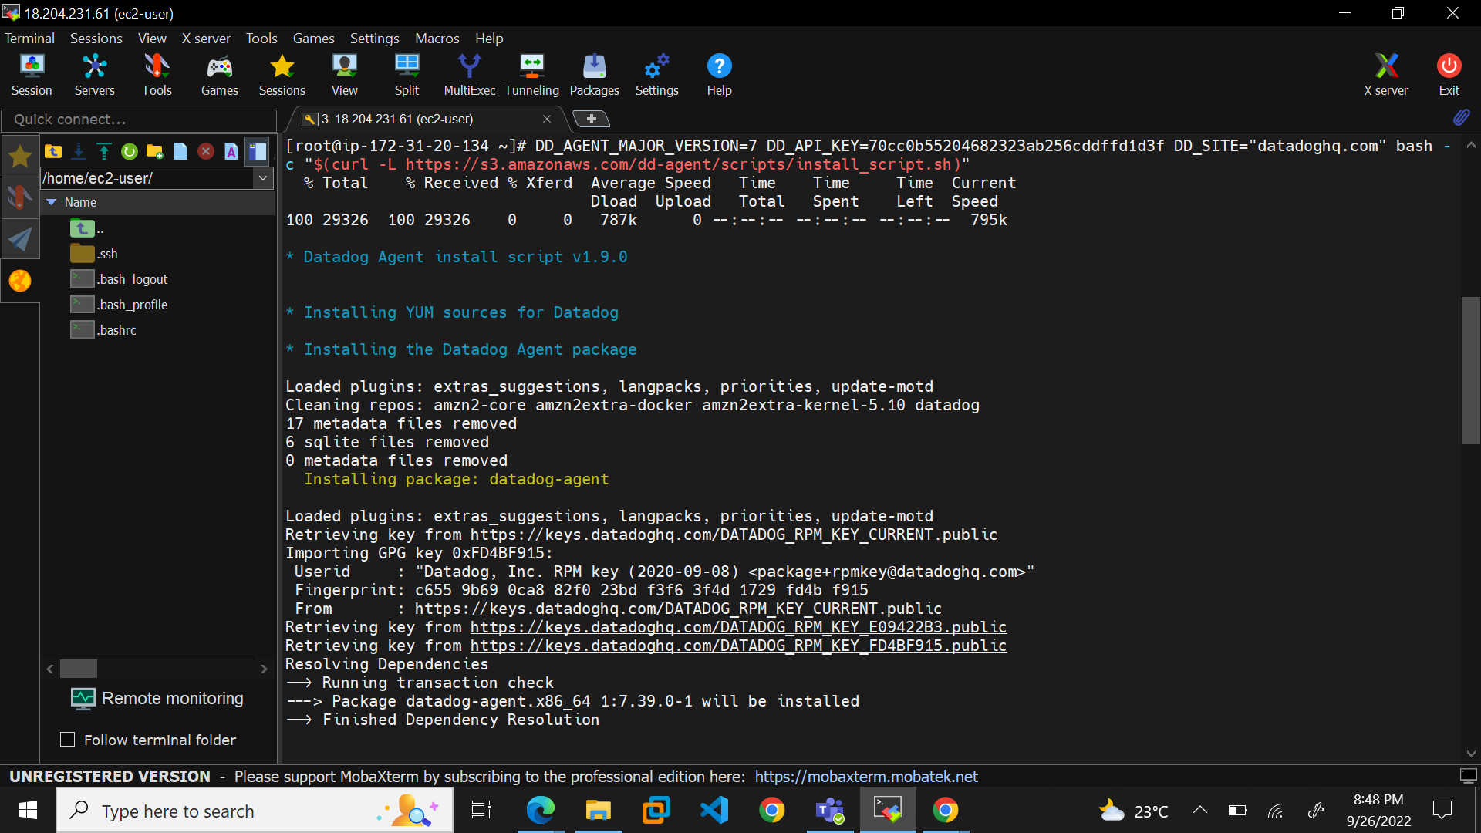

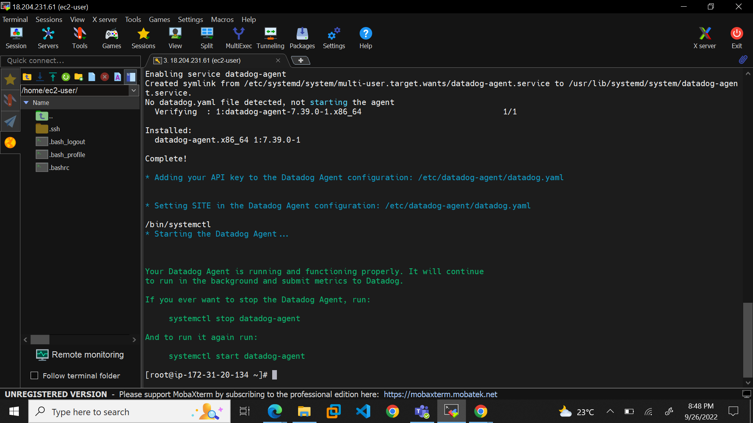

We can check the status of the datadog-agent using the systemctl command

Once the Datadog-agent is up and running, the data starts being sent to the Datadog server,

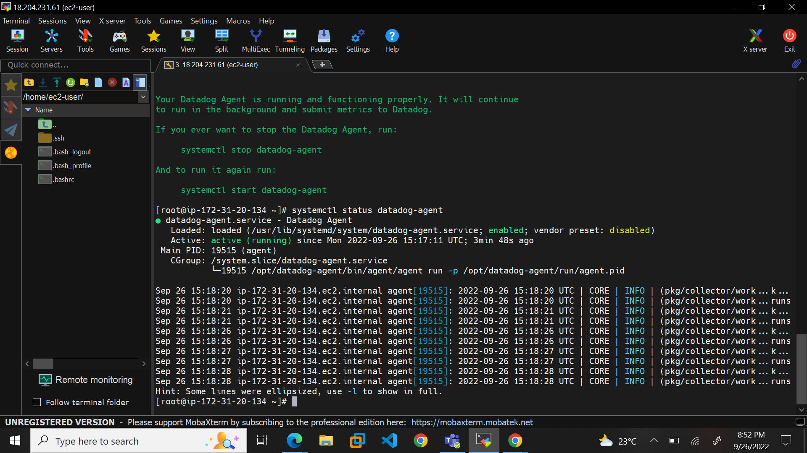

We can navigate to the infrastructure list to check if the EC2 instance is visible

We will be able to check the metrics of the instance in the dashboard

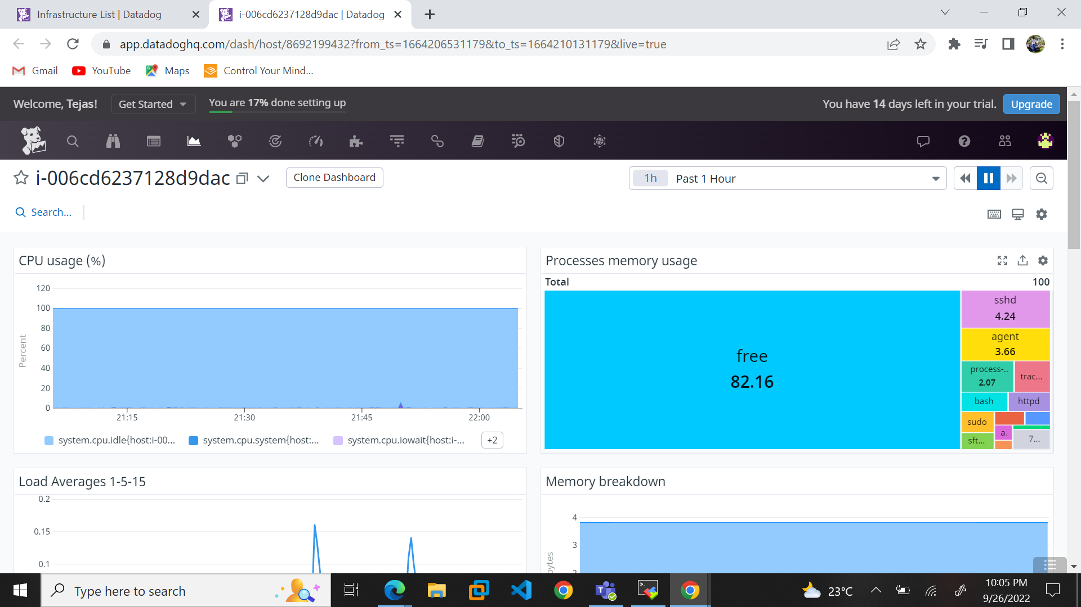

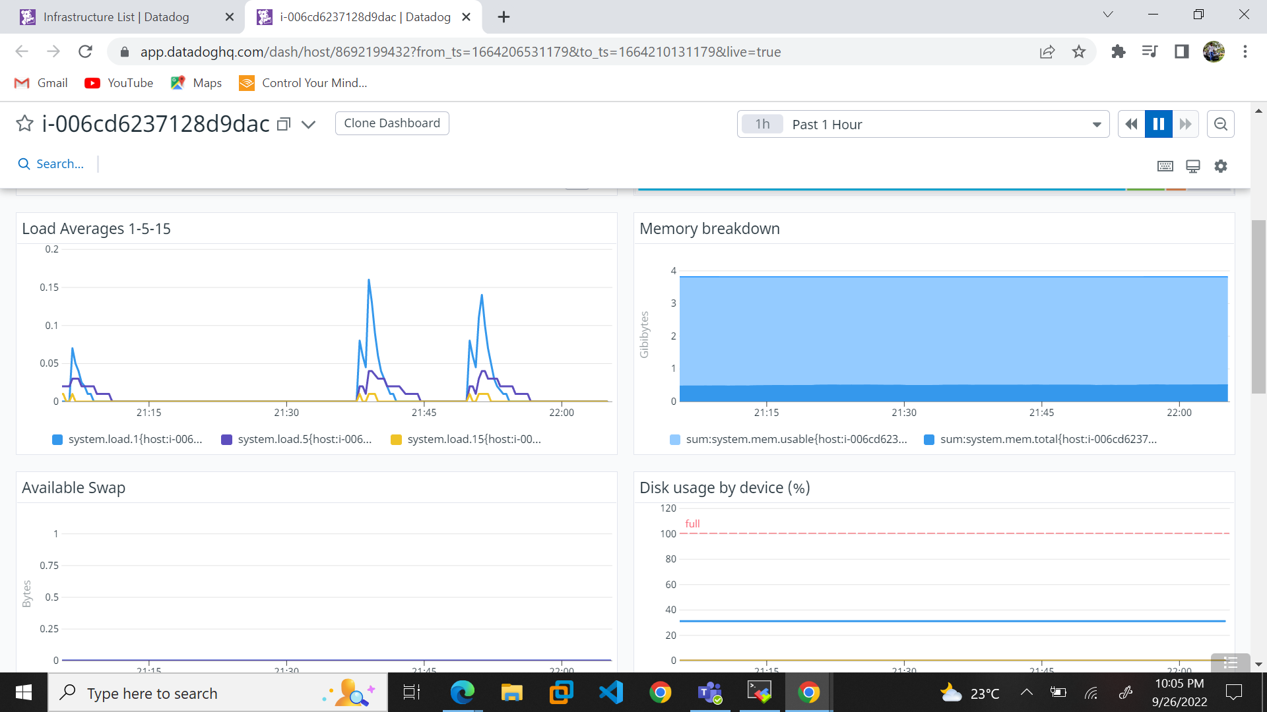

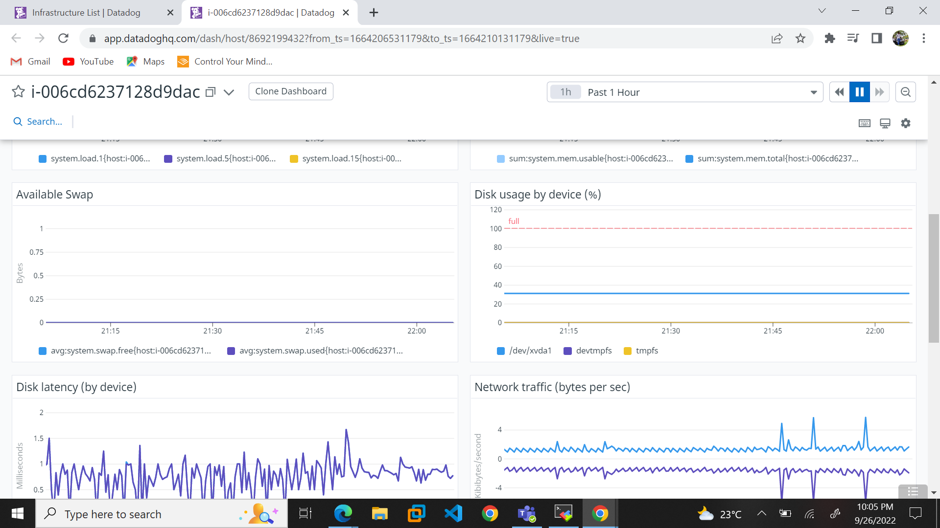

Install httpd service using the yum command:

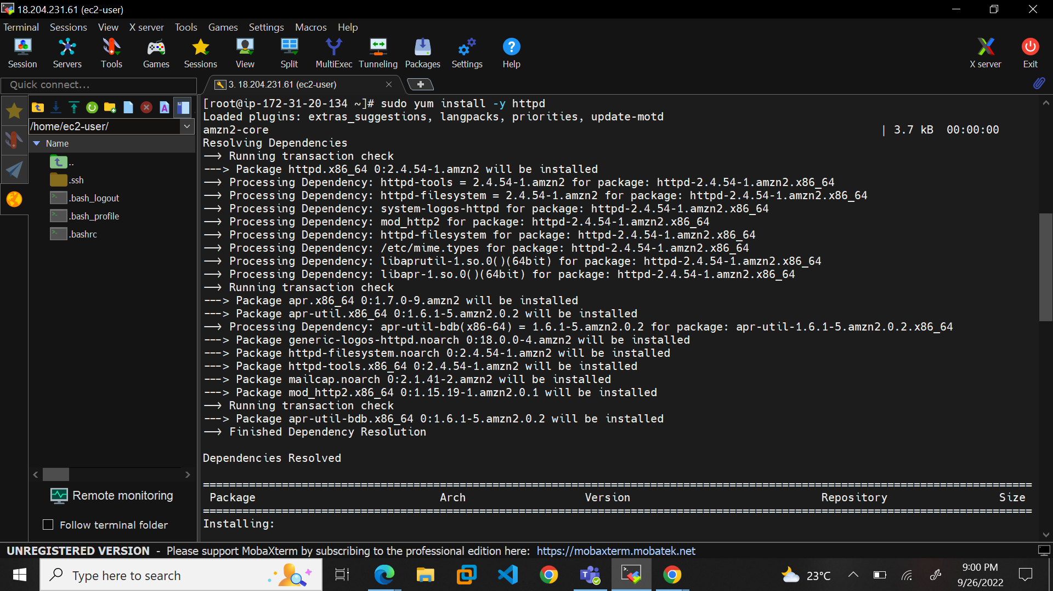

We then start and enable the service using the following commands:

* systemctl enable httpd
* systemctl start httpd
* systemctl status http

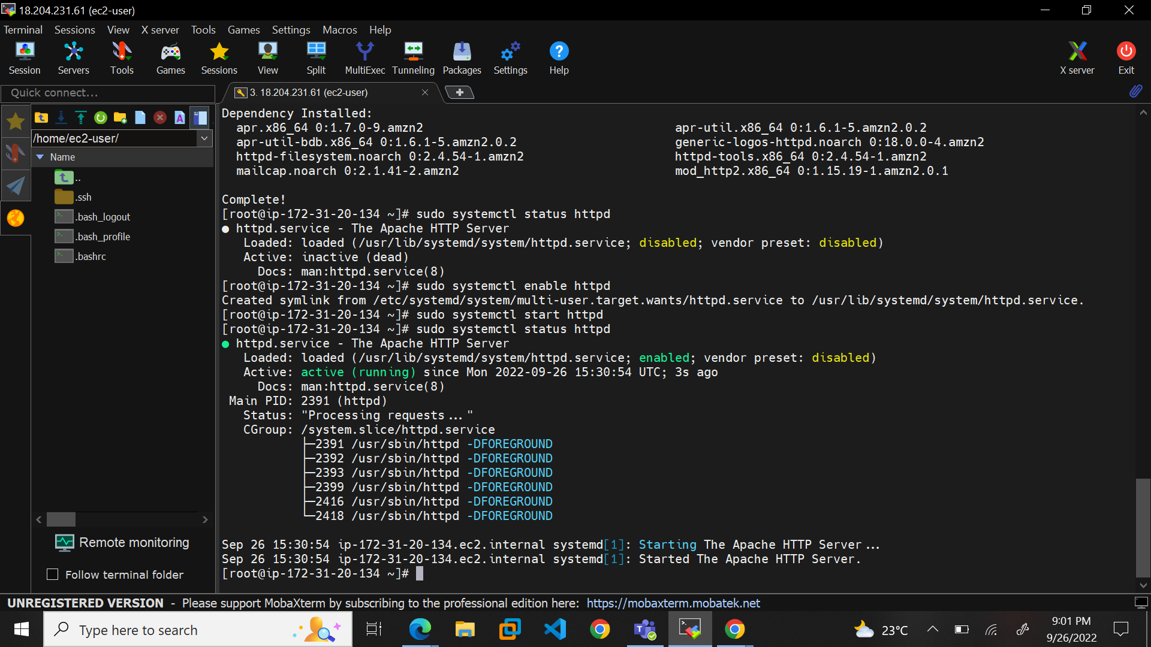

We then configure Apache for Datadog:

We navigate to the config file and make a backup of it:

* cp /etc/httpd/conf/httpd.conf /etc/httpd/conf/httpd_bk.conf

We then configure the httpd.config file and add the following lines:

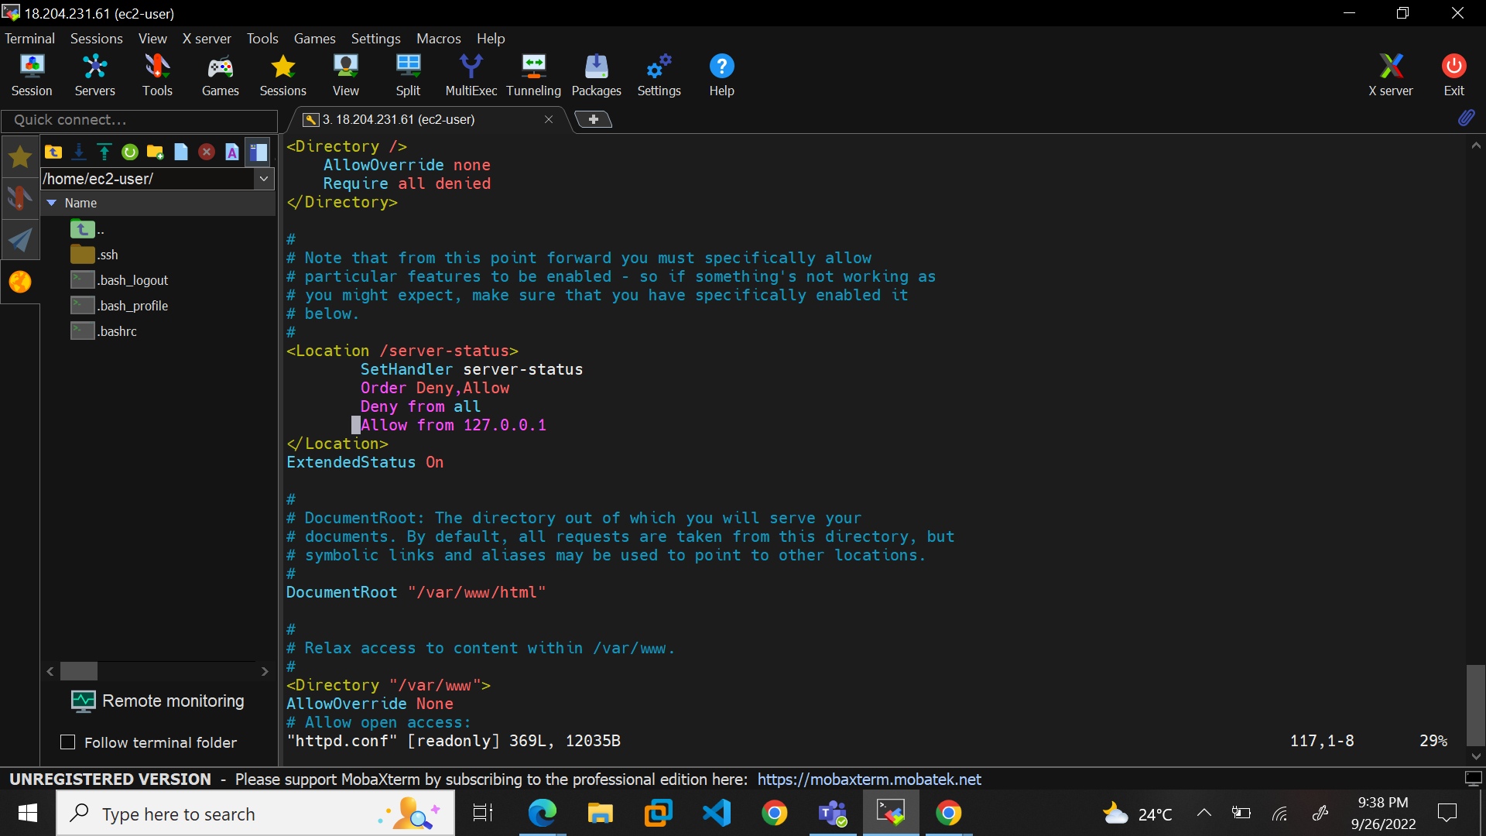

Restart the httpd service after configuration

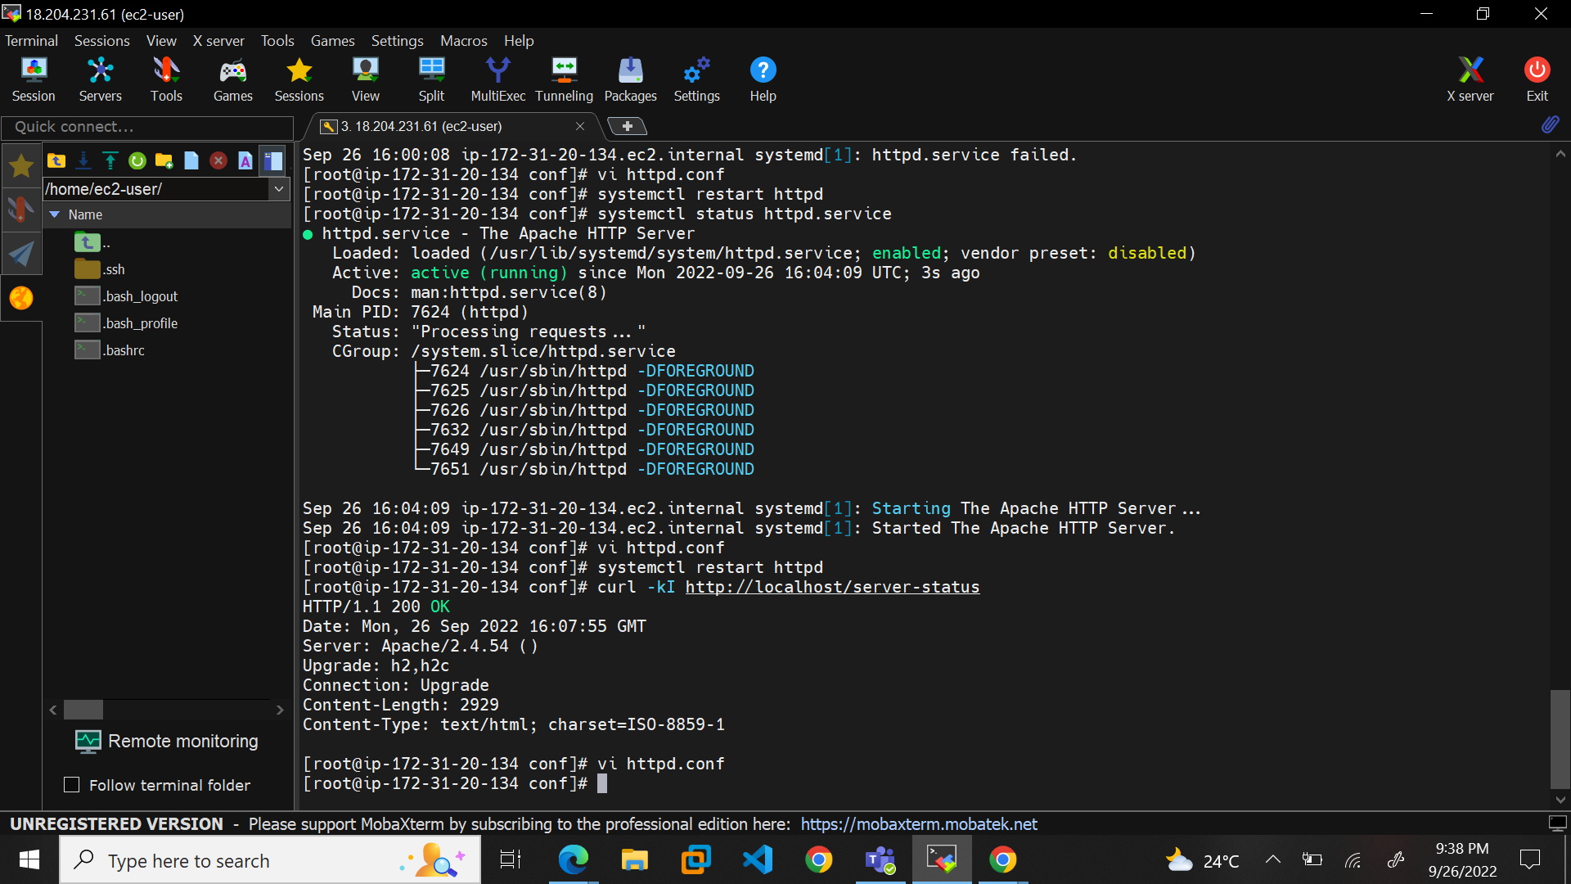

Now we will configure Data Agent for Apache

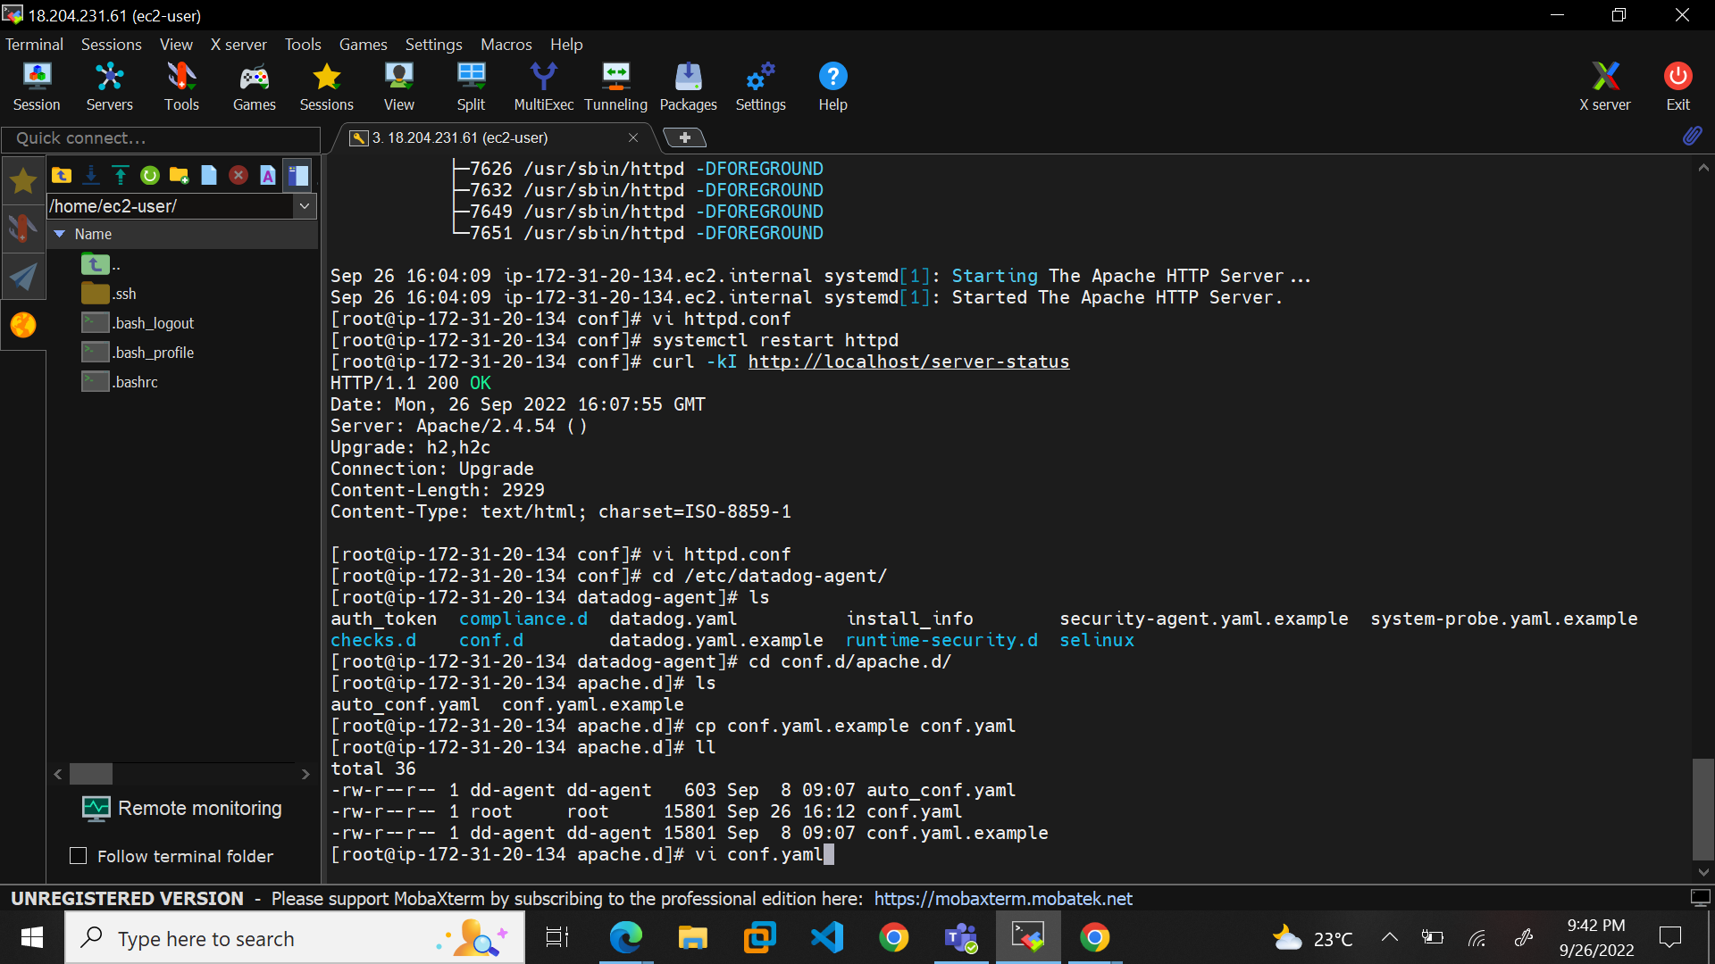

We now configure the config file in the location “/etc/datadog-agent/conf.d/apache.d/conf.yaml”

We add the following lines to the end of the config file under the logs :

logs: -

type: file

path: /var/log/httpd/access_log

source: apache

sourcecategory: http_web_access

service: httpd

- type:

file path: /var/log/ httpd/error_log

source: apache

sourcecategory: http_web_access

service: httpd

We grant permission to log in “/var/log”

* chmod 655 -R httpd

Restart datadog-agent and check the status using the following command:

* sudo service datadog-agent restart
* sudo datadog-agent status

After configuring the above files and granting permission, datadog will now be able to fetch the logs and the same can be monitored from the datadog webserver:

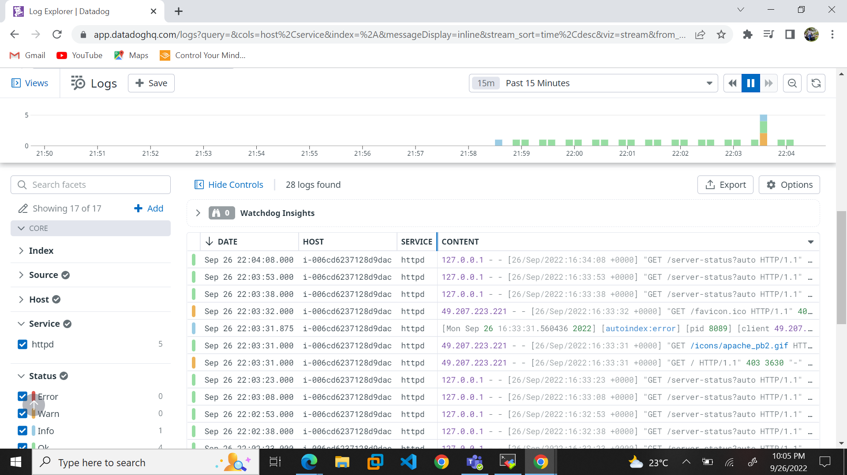

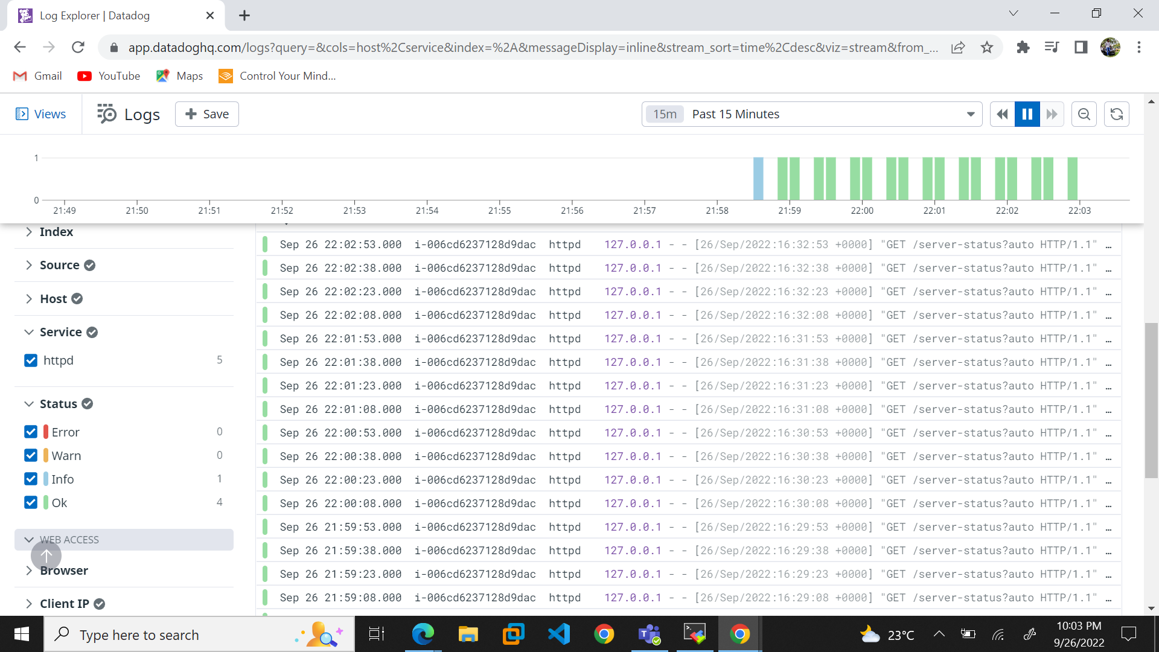

The metrics of the Apache server is also visible on datadog:

